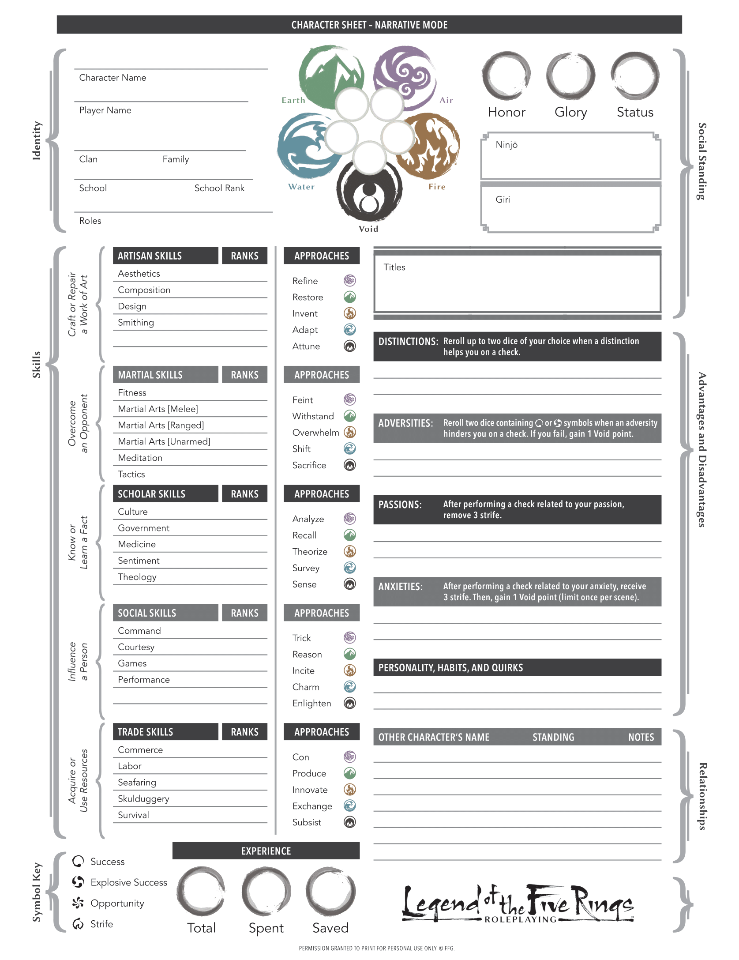

0

0

0

1

1

1

1

1

1

0

0

0

0

0

0

0

0

0

0

0

0

0

0

0

0

0

0

0

0

0

0

0

0

0

0

0

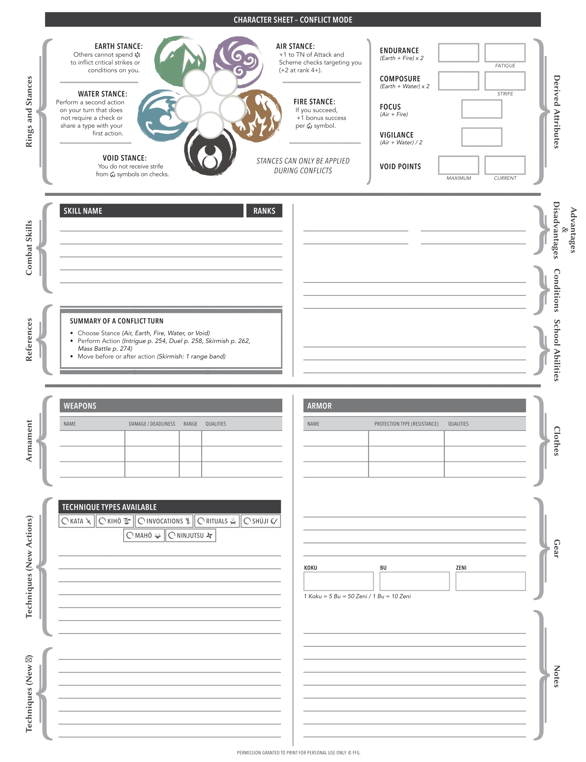

0/0

0/0

0/0

0-0

0-0

0-0

Ph. 0 – Sp. 0

Ph. 0 – Sp. 0

Ph. 0 – Sp. 0

0

0

0

✓

✓

✓

✓

✓

✓

✓

0

0

0

0

0

0

0

0

0

0

0

0

0

1

1

1

1

1

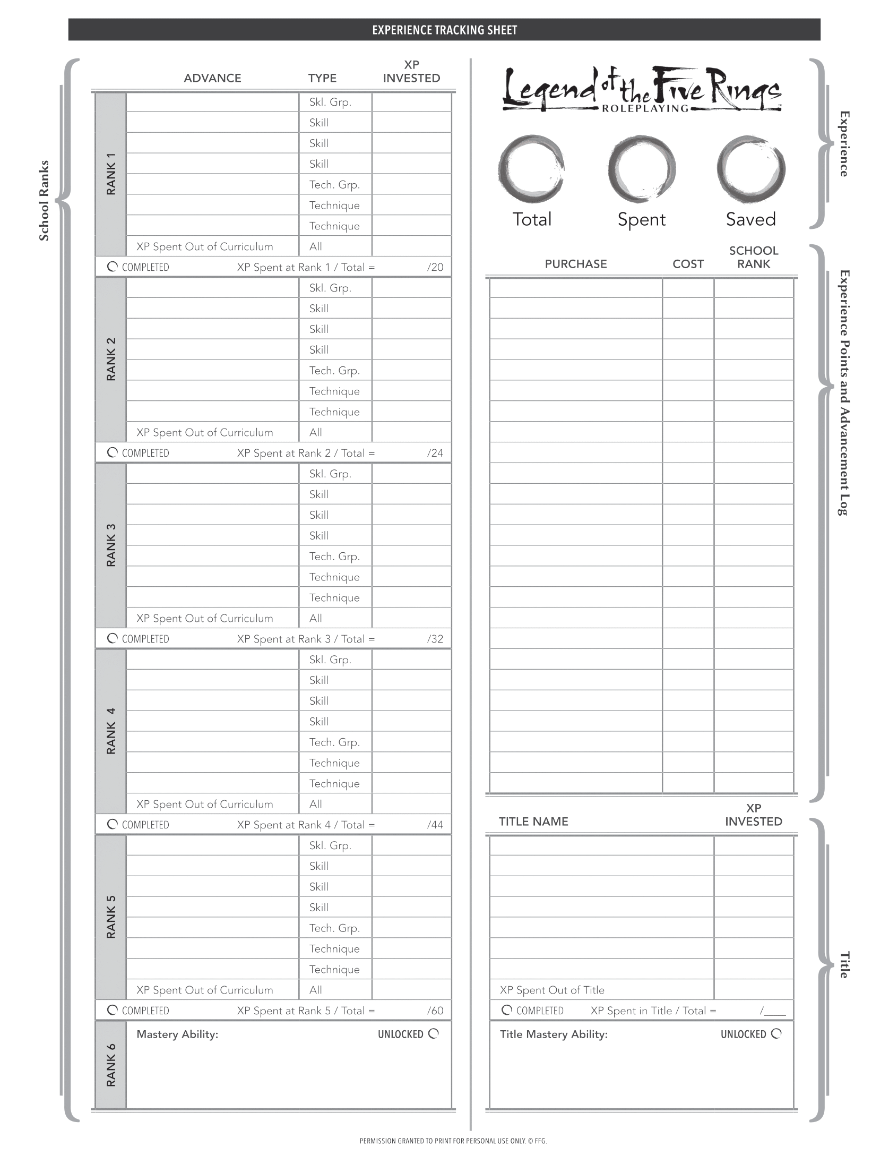

0

0

0

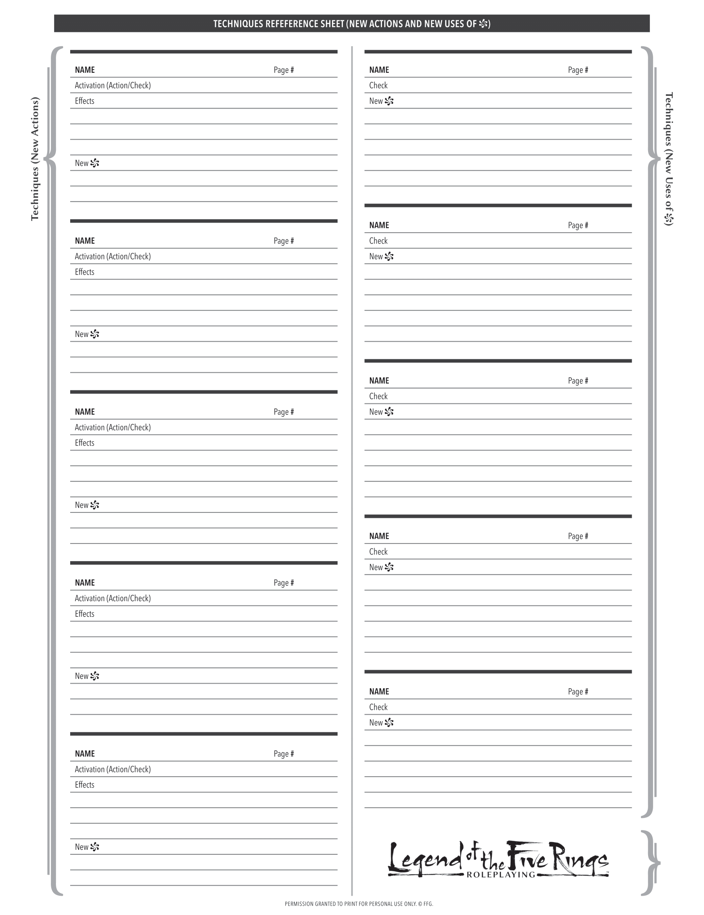

1569